[**DIGITAL SIGNAL & IMAGE PROCESSING LAB**](https://github.com/Amey-Thakur/DIGITAL-SIGNAL-AND-IMAGE-PROCESSING-AND-DIGITAL-SIGNAL-AND-IMAGE-PROCESSING-LAB)

[**EXPERIMENT -**](https://github.com/Amey-Thakur/DIGITAL-SIGNAL-AND-IMAGE-PROCESSING-LAB) **8**

**PART B**

(PART B: TO BE COMPLETED BY STUDENTS)

***(Students must submit the soft copy as per the following segments within two hours of the practical. The soft copy must be uploaded on the Blackboard or emailed to the concerned lab in charge faculties at the end of the practical in case there is no Blackboard access available)***

| **Roll No. 50** | **Name: AMEY THAKUR** |
| --- | --- |
| **Class: COMPS-BE-B-50** | **Batch: B3** |
| **Date of Experiment: 15/09/2021** | **Date of Submission: 15/09/2021** |
| **Grade :** |  |

**A.1 Aim:**

Write a program to implement Histogram Processing.

**B.1 Software Code written by a student:**

***(Paste your code completed during the 2 hours of practice in the lab here)***

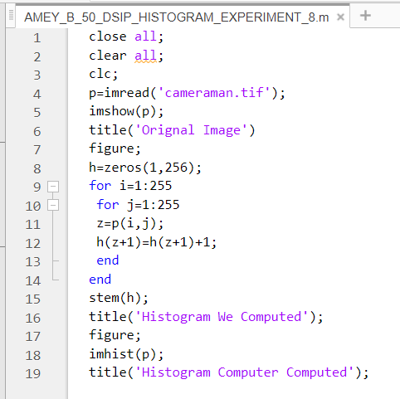

**B.2 Input and Output:**

Original Image:

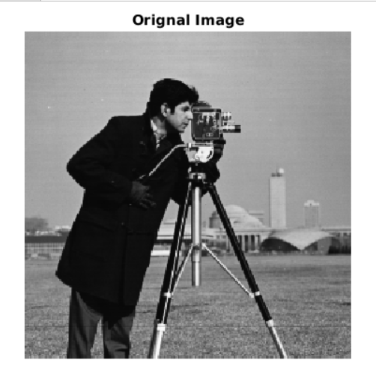

Histogram we computed:

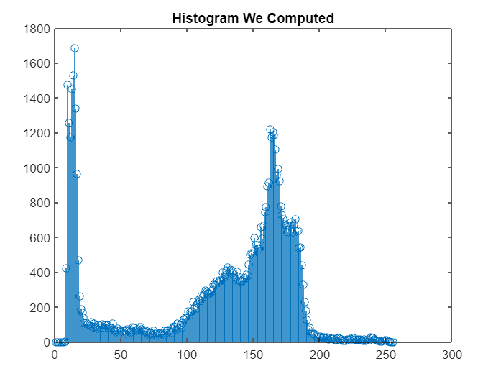

Histogram computer computed:

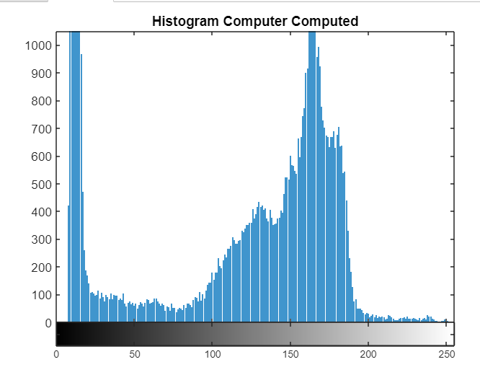

**B.3 Observations and learning:**

***(Students are expected to comment on the output obtained with clear observations and learning for each task/ subpart assigned)***

Histogram equalization is used to enhance contrast. It is not necessary that contrast will always be increased in this. There may be some cases where histogram equalization can be worse. In those cases, the contrast is decreased.

**B.4 Conclusion:**

***(Students must write the conclusion as per the attainment of individual outcome listed above and learning/observation noted in section B.3)***

We’ve implemented Histogram Processing successfully.

**B.5 Question of Curiosity:**

***(To be answered by student based on the practical performed and learning/observations)***

1. What is Histogram?

Ans:

In an image processing context, the histogram of an image normally refers to a histogram of the pixel intensity values. This histogram is a graph showing the number of pixels in an image at each different intensity value found in that image

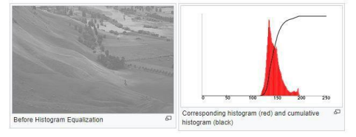

In the above figure, the X-axis represents the tonal scale (black at the left and white at the right), and the Y-axis represents the number of pixels in an image. Here, the histogram shows the number of pixels for each brightness level (from black to white), and when there are more pixels, the peak at a certain brightness level is higher.

1. What is Histogram Equalization?

Ans:

Histogram equalization is used to enhance contrast. It is not necessary that contrast will always be increased in this. There may be some cases where histogram equalization can be worse. In that case, the contrast is decreased.

Histogram Equalization is a computer image processing technique used to improve contrast in images. It accomplishes this by effectively spreading out the most frequent intensity values, i.e., stretching out the intensity range of the image. This method usually increases the global contrast of images when its user data is represented by close contrast values. This allows for areas of lower local contrast to gain a higher contrast.

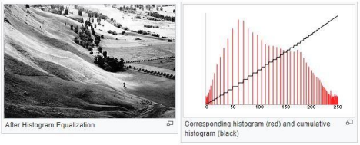

A colour histogram of an image represents the number of pixels in each type of colour component. Histogram equalization cannot be applied separately to the red, green and blue components of the image as it leads to dramatic changes in the image’s colour balance. However, if the image is first converted to another colour space, like HSL/HSV colour space, then the algorithm can be applied to the luminance or value channel without resulting in changes to the hue and saturation of the image.